EPIC ClearViewTM
Algorithm Development
EPIC Scoring

EPIC Research & Diagnostics, Inc.
8501 E Princess Dr. Suite 100
Scottsdale, AZ 85255
USA
(480) 477-5242 Phone
(480) 292-7933 Fax

Originator:
Name | Job Title | Signature | Date
Andrew Mason | Chief Technology Officer
Approvals:
Name | Job Title | Signature | Date
Nancy Rizzo | Founder and CEO
Mike Stowell | V.P of Operations
Brian Tompson | Software Engineer
Andrea Miller | Quality Assurance Manager

Introduction

The EPIC Scoring algorithm is a process that transforms images collected by the ClearView scanner into a quantified assessment of the level deviation a particular organ system may have from the norm. This quantification is achieved through the acquisition of data from the collected images through a complex set of image description calculations. These data points are then processed through a series of calculations and rules to create a score for the particular organ system component. The score is then normalized to a 0-25 point scale to produce the final value to be used in reporting.

Conceptual Theory (light to resistance)

Dr. Rizzo’s doctoral thesis served as the basis for the theory behind the ClearView technology. The ClearView technology translates the electrical signal created when a finger is put in contact with the ClearView electrode.

Dr. Rizzo has studied the imaging of the Galvanic Skin Response for over a dozen years. Throughout that time period she has performed thousands of scans. As a result of that learning process she was able to mathematically categorize the image characteristics, in an effort to prioritize and quantify the results.

It has been demonstrated that the greater the level of disorganization within the images captured from the subject, the higher possibility that the subject has the potential to have an anomaly in the related organ system.

To quantify the level of disorganization within an image, the following coefficients were developed. The ClearView scan coefficients are characterizations of the physical attributes of the scan images. When a scan is conducted, the images from all 10 fingers are divided into 78 sectors. Each sector is then described using the 19 ClearView scan coefficients. This sectoring process is defined in Finger Sector Map (SS-203-01).

Development Data Used

The foundation of the final algorithm was developed using a data set consisting of 690 participants. The general demographic breakdown of the population is described in the figure below:

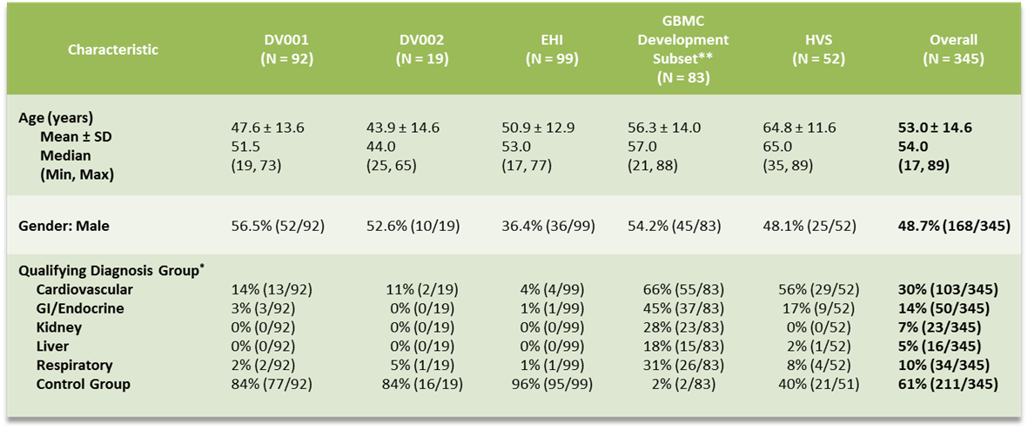

Scoring Model

Once the coefficients have been collected as described in SR-203-01, they are run through a series of steps in order to arrive at the final score. This is done independently for both the capacitive barrier measurements as well as the non-capacitive barrier measurements. The following outlines the steps that are taken in order to generate the final score, further detail (such as the actual factors and values to use) is provided in SR-203-01.

  - The base score for a given sector will be derived by adding together the values of all the normalized coefficients for the selected sector.

    - The standard mean and standard deviation are calculated. In order to further mitigate outliers, a check is done to determine of any of the values in the coefficient set are outside of 3 standard deviations from the mean. In the case where this is true, the mean and standard deviation are calculated again after removing the coefficients that fall outside 3 standard deviations from the mean. The final mean and standard deviation is then used to calculate the Z-score of the coefficient.

    - Once the Z-scores are calculated for all coefficients (except for AI4, Ring Thickness and Ring Intensity), the base score for the coefficient for each sector will be determined by multiplying the base raw value of the coefficient by the z-score and multiplying that by the normalization factor for the coefficient. The normalization factor is used to equalize the weight of the coefficients.

Note: AI4, Ring Thickness and Ring Intensity have the possibility of being mostly zero in a subject, so the Z-score is not used for these coefficients.

The next component of the score is referred to as the significance score for the sector. Based on the review of large quantities of images over many years, particular patterns of behavior have been noted. These patterns are express in the form of specific combinations of coefficients being recognized as outliers. The significance score component applies the patterns through the use of rules that are applied to the coefficients for a given sector. If the rule (all are defined in SR-203-01) is true for a given sector, the Z-score is appropriately incremented.

The final score for the sector is determined by adding the base score to the significance score.

The final score is then normalized using a scaling mechanism that will result in a score of 0 to 25 being produced. The scale was developed during the analysis phase.

The Scoring Model Applied

When the scoring model was applied to the population specified in section 3 above the results are summarized in the table below. This table represents the odds ratios for a 5 point increase in the EPIC score for the given organ system. The odds ratio is the mathematical representation of the results of the EPIC Score assessment.

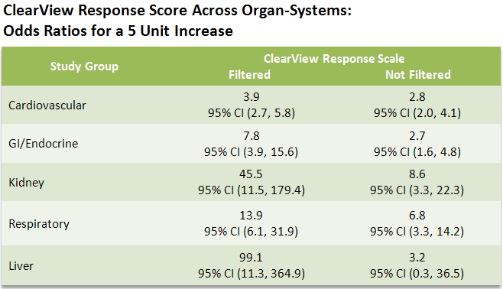

As an example, for every 5 point increase in the EPIC Score, there is a 99.1 to 1 probability of an associated issue with that organ system. This is equivalent to a 1000% increase in the likelihood that the subject has an issue with the particular organ system.

The odds ratios were calculated using a statistical model in SAS by EPIC’s CRO, NAMSA. This model is controlled through NAMSA’s recordkeeping procedures and can be located through their documentation controls. EPIC may choose to place a version of this documentation in EPIC’s documentation system at some point in the future.

Reference Documents

SR-203-01, Algorithm Requirements
SS-203-01, Finger Sector Map

